Assessment Workshop, NSIP 2017

Where the group got to in 2016: 1

Background 2

Modelling of assessment: general principles 2

Primary Education Assessment Data 5

Secondary Education Assessment Data 7

Information that needs to travel with the student: 9

NEXT STEPS 10

Appendix 10

NZ requirements: 10

NZ Assessments and Achievements 11

Primary 11

Secondary school assessments and achievements 11

Achievement Results 11

Options for Data Objects 11

Australian Context 11

# Where the group got to in 2016:

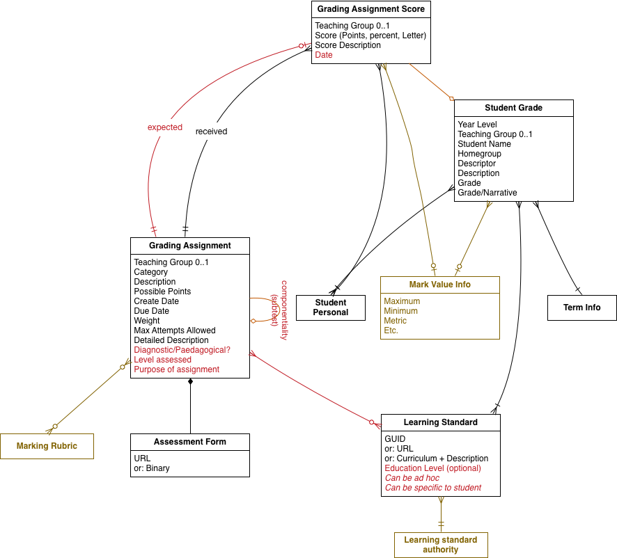

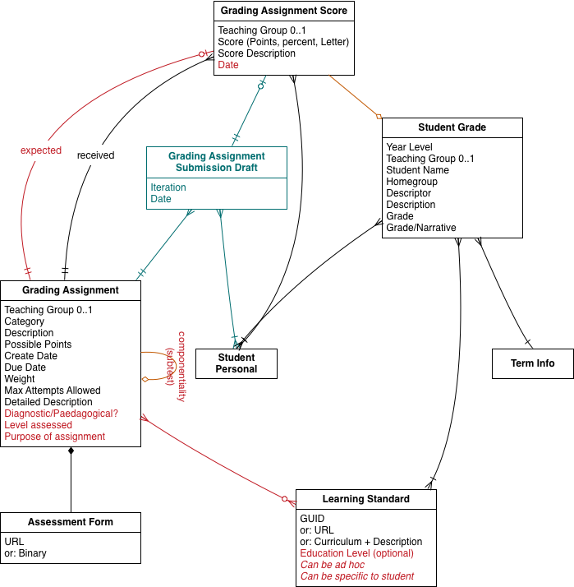

# Background

See Appendix: Capture of first day’s discussion

# Modelling of assessment: general principles

Assessment can be viewed retrospectively, as the diagnosis of a student’s academic progress. Assessment can also be viewed prospectively, as an activity to be prepared for and put though (e.g. printing out exam booklets). The data model needs to be able to deal with both perspectives on assessment.

The retrospective view of assessment is catered to by streams of information about assessment facts. The prospective view of assessment is catered to by streams of information about intents of assessment — which provide context for the assessment facts they bring about.

Other pieces of context to be tracked include:

* Special circumstances around scoring, which inform how the score is to be interpreted
* The educational pathway of the student, which inform how the assessment is to be interpreted in a way useful to the student

The effectiveness of assessment also needs to be tracked, in order to help improve the effectiveness of the assessment instruments.

There are different types of assessment, including different modalities/methods of delivering the assessment, and different intents behind the assessment. These can be captured to a more or less granular extent.

There are different consumers of assessment data, who have different purposes behind consuming the data:

* Psychometricians, concerned with the effectiveness of the assessment instruments
* Schools, concerned with the assessment results
* Assessment authorities, concerned with assessment administration
* Teachers, concerned with remedial learning based on assessment

Use cases for the exchange of assessment data include:

* Student transfer between schools (whether within a school authority or between school authorities)
  + There are potentially different granularity requirements depending on what school the student is moving to
* Assessment as Business As Usual administered within a school
* Reporting
  + External/Vertical Reporting
  + Reporting to teachers or parents within the school community
* Remedial learning, informed by assessment. (This requires high granularity of data, down to the individual question level)

There are calls for both granular and aggregated summary data about assessment, for different purposes. The granularity of data to be consumed is open-ended, and should only be decided by the consumers. The raw data and the summary data are two distinct data services, and it is a business choice which of the two to consume from.

Summary data may need to be provided as a service by a more experienced party, who is capable of extracting the right data for a particular purpose: the interpretation of data should not be undertaken only at the edge, locally, when there is expertise and a more global view of assessment available centrally by aggregators.

The pedagogical context of the assessment should ideally be recoverable; that is not always possible, particularly for ad hoc online assessments.

We will differentiate two workflows to establish what is needed for assessment objects:

* Primary education: limited and simple assessment resources, few parties engaged with assessment (no psychometricians or assessment authorities)
* Secondary education: more parties involved in the exchange, more complex assessment instruments

Need to model qualifications and achievements which result from one or more assessments

* NZ has Course Endorsements, which are tailored to students.
* These also go into the student transcript

Validation, contextual data to be differentiated from core data.

Not all relations between data need to be transferred between schools: often only summary data is. However there will be different judgements in what is necessary to transfer, and sometimes it will be necessary to send details of assessment events.

Conversely, the amount of context that needs to be made explicit will be far less within an enterprise; e.g. evidence of eligibility. Some context is presupposed by virtue of the fact that the assessment has in fact succeeded and generated a score. A preliminary handshake is needed to establish how much context needs to be exchanged.

The underlying stream of assessment facts that has motivated the aggregate summary data needs to be captured, even if it is not to be transmitted, as an audit trail.

# Primary Education Assessment Data

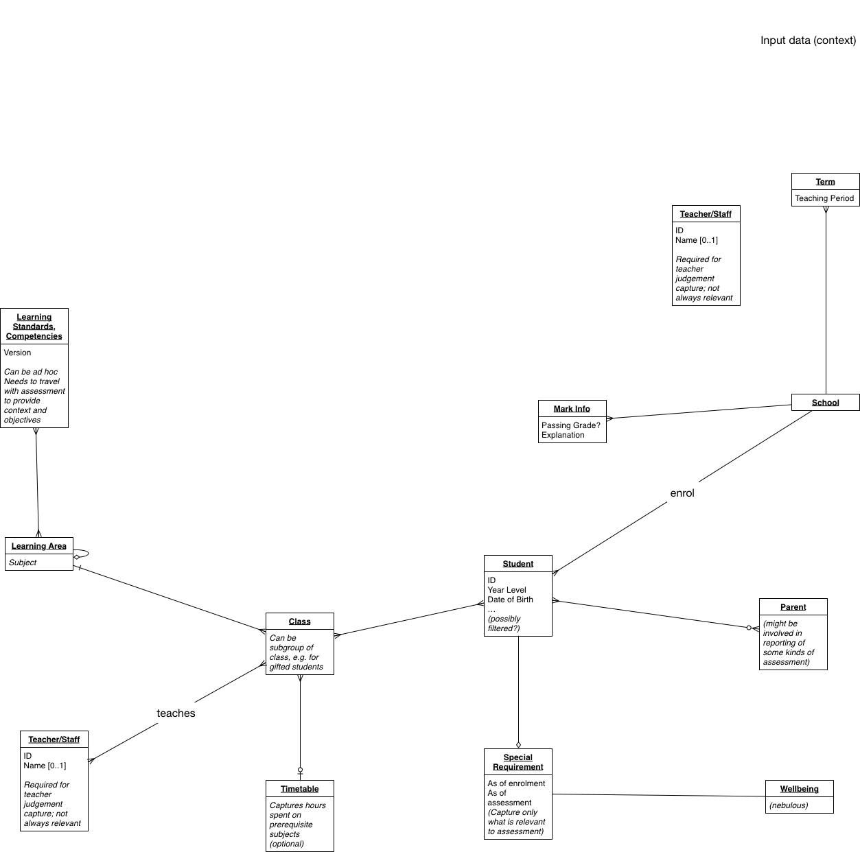

**Objects new since 2016:**

* **(Learning Area)**
* **Special Requirement**

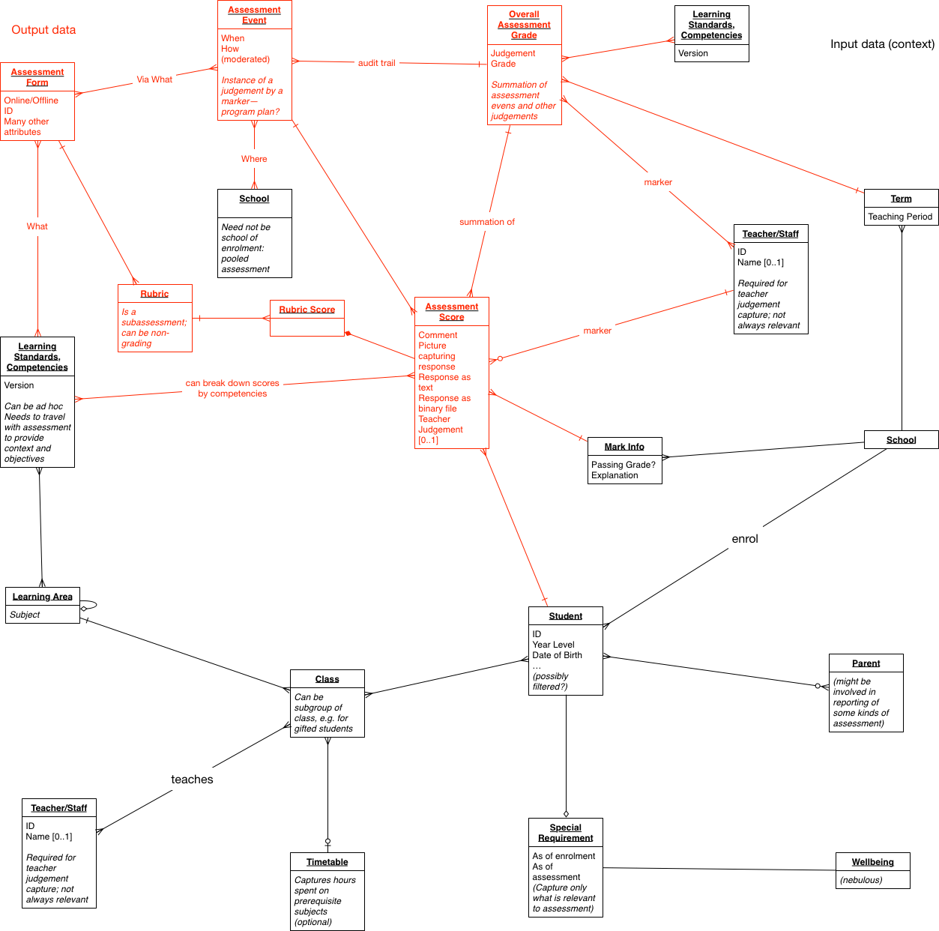

**Objects new since 2016:**

* **Rubric**
  + **Can be modelled as marking guide, or as subassessment**
* **Rubric Score (as component of Assessment Score)**
* **Assessment Event (to the extent it cannot fit into Grading Assignment)**
* **Assessment Form (currently just attribute of Grading Assignment)**
  + **Object needs to be designed so as to allow different granularity: option of representing individual assessment items (as recursive link to other assessments)**

Prerequisites to assessment (not depicted) can include attendance, other assessments, and recognition of prior learning.

Recognition of prior learning (RPL) involves a student arriving with a set of assessment data at a new school, and the receiving school making sense of this data.

* An LMS needs to process granular assessment data
  + But it may not need to store such data in the long term, after the initial evaluation of RPL. This is a business decision.
  + In the case of systemic school authorities, a feed of the data transferred for RPL will continue to be made available from the central hub
* An SMS may well only need to process summary data

The assessment data services need to provide CRUD functionality (including update) on their objects.

* There is an open question of what the minimum addressable level of assessment instruments is—e.g. whether individual questions need to be tracked. The default addressable level is going to be whatever is recorded in the markbook, and markbook design is informed by that concern.
* There is an open question of how levels of granularity are to be defined: what level of information is available, and should be asked for? This will be established through handshake, and will be made explicit through objects such as MarkInfo.
  + There will be a hierarchy of summary data available at different levels of aggregation; this hierarchy needs to be self-documenting, through attributes of the grade assigned at that level.
* Shared knowledge is often presupposed; it needs to be scrutinised for any assessment data exchanges.

# Secondary Education Assessment Data

* Need to track what standards have contributed how to qualifications and achievements.
  + May need to break this down to the level of credits contributed by each standard attained.
  + Student movement between schools needs not to undermine the calculation of how credits add up to an achievement: a student that moves schools needs both their prior and current credits to be counted.
* Classes and courses are not coupled tightly.

Modelling qualifications:

* Increasingly, qualifications are no longer rigidly rule-bound, and can be achieved in more ad hoc pathways.
  + Qualifications need to be kept loosely coupled to standards and assessments.
* Qualifications, like assessments, can be prerequisites to other assessments (or qualifications)
* In data modelling, qualifications look a lot like assessments. It is still expedient to model them separately from assessments: they are quite distinct from the perspective of the business. Modelling may identify commonalities between them.

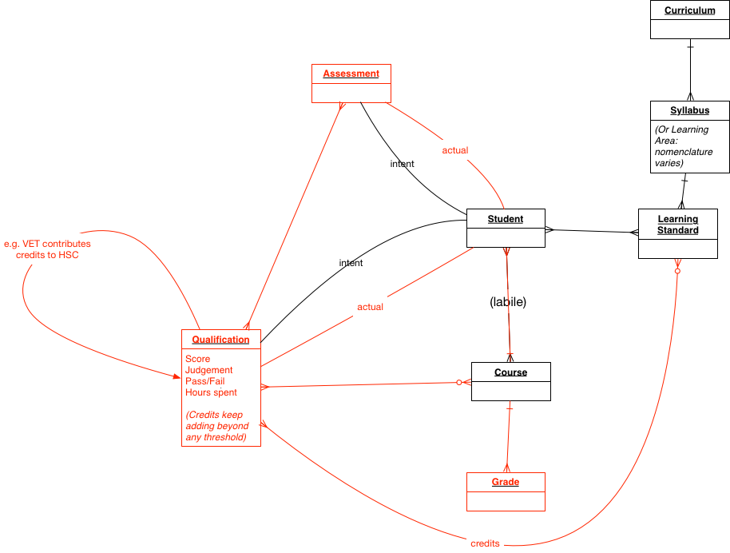

**Objects new from 2016:**

* **Qualification**
* **(Course)**

Teachers are somewhat involved in the secondary assessment data model, as delivering mock exams.

Assessments can be administered repeatedly over time of the same competency with the same student, in order to demonstrate consistent or improving achievement.

The school receiving a transcript will not have the same courses as the school sending the student; so they will require context to interpret the prior learning represented, and they may not end up caring about the prior courses at all.

* The course endorsement matters more for the receiving school as an achievement; but courses can still be consumed by external stakeholders as RPL.

Often in Australia no qualifications are tracked beyond Year 10: the Year 12 structure of assessment can be simpler, and involves reduced curriculum tracking. No courses are tracked in VIC, although they are in NT and WA.

For New Zealand the point of courses is to gather up credits against learning standards, without dictating the learning material to be followed. In VIC, the situation is the reverse.

Education Pathway:

* Courses have separate enrolments. The relationship is with a learning provider, and with the qualifications authority, not primarily with the school.
* Enrolments for students into courses are however tracked in the school SMS, and are transferred between schools as students move.

Special Requirements in Secondary are more formal, and involve more roles in approval and as consumers.

* Wellbeing is still tracked against entry (= registration, enrolment) into courses and qualifications, as Personal Needs & Preferences (PNP)/Adjustments. The PNPs need to be passed on.
  + PNPs are information specific to assessment, but they are informed by wellbeing.

Individual learning plans can travel with the student as part of their transfer note.

Special circumstances for assessment: they are tracked on assessment registration, based on information in the wellbeing objects or the pastoral record of the student.

Aims specific to secondary assessment:

* Administration of assessment
* Improvement of assessment
* Remedial learning: granular alignment of assessment to learning standards

Interim and final assessment need to be differentiated. Provisional and final score need to be differentiated (not scaled in NZ, scaled in VIC).

Score moderation involves a number of statuses, and these need to be captured and move with the student.

Language of examination and of the answers in an assessment need to be captured for NZ.

Script personalisation (preparatory activity for administering assessment): NZ allocates markers in advance, for probity and routing. If a student moves, the marker may need to be reassigned.

Improvement of assessment instruments (psychometrics): needs to know: method, format, mode of delivery, special requirements, demographics.

# Information that needs to travel with the student:

* Entry (registration and enrolment)
* Learning standards
* Contribution of learning standards, courses, and assessments towards qualifications and achievements (+ level, + details)
* Not urgent for qualifications to travel. Qualifications don’t need much detail to be specified: a mere label is enough at the secondary level. Admission into tertiary do need much more information.
  + May still need RefID, but these are thin objects. Codeset may end up externally hosted, in line with current thinking about the future of SIF codesets.
* Results
* Course endorsements = achievements. (Limited use for new arrivals in a school: they are fetched at the start of the new enrolment to make an RPL evaluation, but are not used on an ongoing basis.)
* Special requirements

# NEXT STEPS

Denormalisation of conceptual model into logical model will be done by NSIP in collaboration with workshop participants. Australia is lagging behind New Zealand, and New Zealand have more specialisation in their requirements.

* Apply all the requirements captured in this document against the class diagrams, and expand out their attributes as needed. Specialise any objects that require it.
* Reconcile the class diagrams with the class diagrams that came out of 2016.
* Derive a first cut logical model based on the class diagrams
* Import into that logical model available prior art (notably the SIF3 Assessment objects, the NAPLAN objects, the NZ data modelling work)
* Circulate logical model for discussion.

# Appendix

## NZ requirements:

* Prime driver: Info sharing project (SISI), NZ want student mobility to fully inform about the progress of incoming students against standards.
  + Context: Schools are highly autonomous: Education Department rarely gets to require things of schools. Lots of Maori language delivery, and different learning standards in Maori.
* NZ: mock exam results are sent back just in case. Provisional, final, interim. They repeat required acts of assessment in some assignments, e.g. demonstrating increased mechanical aptitude.
* NZ want examiner reports to feed into next year planning, at the level of the individual question, with quick iteration. (Higher granularity requirement)
* High stakes assessment: a student needs need to be enrolled towards a certificate/award/eligibility, else there is no stake for the High stakes assessment. Studies > Study Designs > Assessment Plans is how this is organised in Vic, which formulates how assessment is atomised. Much front ending on enrolment to ensure data this builds on is accurate.

## NZ Assessments and Achievements

### Primary

* PAT. Uses scale scores and stanine. STAR: supplementary test of achievement in reading; has subtests. IKAN: maths test against competencies.
* National standards: assessment standards, including results on assessment on how well they have performed against the standard (individual scores, as well as Overall Teacher Judgement for grade evaluation). Progression is consistently recovered by using the same levels across all assessment. OTJ is attempt to provide a single assessment; disability ignores it because it is not fitting, and some schools don’t trust it because it does not rely on the tests they want.
  + National standards have been in place for 5 yrs.

### Secondary school assessments and achievements

National Cert of Educational Achievement, managed by NZQA. Course offering aligns to NCEA, will differ in details, including standards, which may vary at the level of individual student (advanced placement into assessment.) Assessment against standards for each course, with credits. If you fail to get the credits, you can re-sit, unless externally assessed; no partial credits. Credits and standards tightly coupled.

Cambridge mathematics, International Baccalaureate. Want to be able to exchange information about them. Map to standards. NZQA don’t hold any info about Cambridge standards, only the sharing project will try to be across it, and it may yet be ruled out of scope. Will need to be geared later on to tertiary admission, have not had the mechanism until now to capture that; Recognition of Prior Learning.

### Achievement Results

Listing of standards vs credits and results and dates in a transcript: NZQA Record of Achievement, including NCEA.

Curriculum = Programme + Component + Learning Standards + Competencies.  
Tertiary: Programme Completion => qualification  
Secondary: credits from learning standard => qualification  
Primary: assessment against learning standard => score

Secondary achievement: based on rules around credits received. NZQA have no notion of qualification entry: is only determined based on standards.

### Options for Data Objects

Mapping exercise to SIF-AU. Have a detailed model for what they need at the logical data object. (will need to run against our full conceptual model of assessment.) Will need to model achievements.

## Australian Context

Curricula: NT have their own, some curriculum modelling in NSW but not shared. NESA syllabus, schools independent and don’t provide much info back on alignment.

Need to evaluate effectiveness of assessment tools, and continuous improvement loop.

NSW: request for interest to marketplace for vendors to assist them in developing a data model. Need types of assessment, and connected learning outcomes; measure of how effective assessment was; want to know how the vendor has already solved this issue. Cannot compel all schools to adopt their solution anyway, as with other use cases for NSW data hub.

There is a divide between the systemic standard curriculum requirements and what the schools actually record against their assessment. There is a diversity of use cases coming out of schools.

Recording evidence from summative assessment should reinforce summative score. NZ: Teacher summative judgement is fallible: teachers in primary under-score or over-score if they are not teaching the entire curriculum, which leads to inconsistencies when they hit secondary.

Schools are using many assessment tools, the centre needs to cope with that. ICON project: their BI platform will visualise all assessment objects received back to teachers and parents, as part of summative reporting. Point of differentiation for vendors is visualisation, not data format. Raw material will be different in different contexts, but should be such as to allow the most value to be recovered from it. Need contextual information for assessment. Schools choice promotes context as well: different schools will use different cutoffs, for example. The reporting guidelines in VIC have become more flexible, and not standardised, which is more of a challenge.

At the recording level, no difference between summative and formative: audit trail of an even stream of assessment. Conceptual divide still needed; otherwise preempt the reporting objects around them. Learning Standards need to be publicly available.

Longitudinal reporting: needs to cope with schema migration.

Totalising solution does not work out because need to keep migrating data. Context provision should be lightweight like a link; but the stuff goes away. Ingest it into the standard, and you can guarantee that it stays with your data. What is exchanged is outside of scope of standard, it just facilitates the exchange. It is not the role of the standard to provide the context in the exchange.

There is call for profiling standards locally, as NSW does.